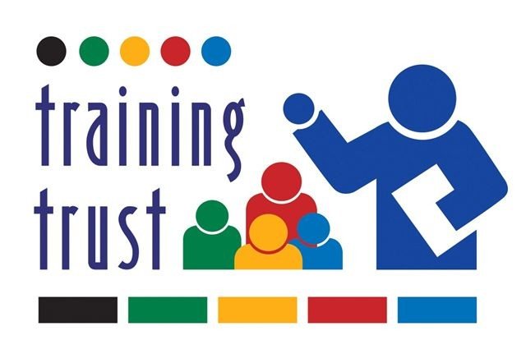

HEALTH AND SAFETY POLICY STATEMENT

The Training Trust is aware of its obligations under the Health and Safety at Work Act 1974 and will as far as is reasonably practical ensure the health, safety and welfare of all employees and learners.

In particular, the Training Trust will:

- Provide and maintain safe and healthy working environment considering any statutory requirements.
- Provide training and instruction to enable employees and learners to perform their work safely and efficiently.
- Make available all necessary safety devices and protective equipment and provide training and supervision of their use.
- Maintain a constant and continuing interest in all health and safety matters and will consult and involve all employees and learners.

The chart below indicates persons responsible in the following area:

RESPONSIBILITY | NAME (printed)
Ensuring that this Policy is carried out | Mark Durham  Chief Executive
First Aid: | Mark Durham  Chief Executive
Premises/Equipment: | Mark Durham  Chief Executive
Responsible Persons for Health & Safety: | Mark Durham

Any queries or problems should immediately be referred to the person responsible.

All employees, learners and visitors have a duty to co-operate in the operation of this Policy by:

- Working safely and efficiently
- Using protective equipment provided and by meeting statutory obligations
- Reporting incidents that have led or may lead to injury or damage
- Adhering to company procedures, jointly agreed on their behalf, for securing a safe workplace
- Assisting in the investigation of accidents with the object of introducing measures to prevent a recurrence.

FIRE PRECAUTIONS

All employees, learners and visitors must make themselves familiar with the fire precautions relative to their place of work. It is obviously just as important for employees to avoid any action which may cause an outbreak of fire and as an aid to safety, no smoking rules apply.

If you are not familiar with the company’s regulations, you should seek the assistance of your Manager without delay.

SECURITY

Employees and learners are required at all times to comply with all Policies, Procedures and Instructions given by, or in the name of the Training Trust.

CHIEF EXECUTIVE’S AUTHORISATION

Signed: | Date: 03 September 2024
Name (printed)  Mark Durham | Date: 03 September 2024

